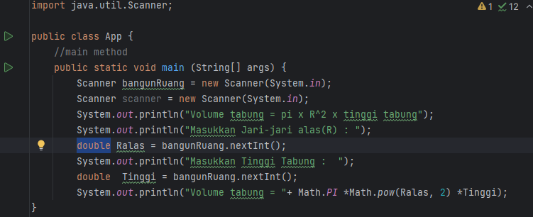

Latihan Rumus Volume Tabung

Percobaan branching

Branching dengan if else if else

Kalang while

Kalang for